上机实验（四）

#include <iostream>

using namespace std;

class TSstudent

{

public:

double money;

static double m_ClassMoney; //202030310218李嘉杰

void InitStudent()

{

}

void ExpendMoney(double a)

{

money = a;

}

double ShowMoney()

{

m_ClassMoney = m_ClassMoney - money;

return m_ClassMoney;

}

};

double TSstudent::m_ClassMoney = 1000;

int main()

{

TSstudent A;

TSstudent B;

TSstudent C;

A.ExpendMoney(50);

cout << "班费还剩余" << A.ShowMoney() << endl;

B.ExpendMoney(98.5);

cout << "班费还剩余" << B.ShowMoney() << endl;

C.ExpendMoney(500.53);

cout << "班费还剩余" << C.ShowMoney() << endl;

}

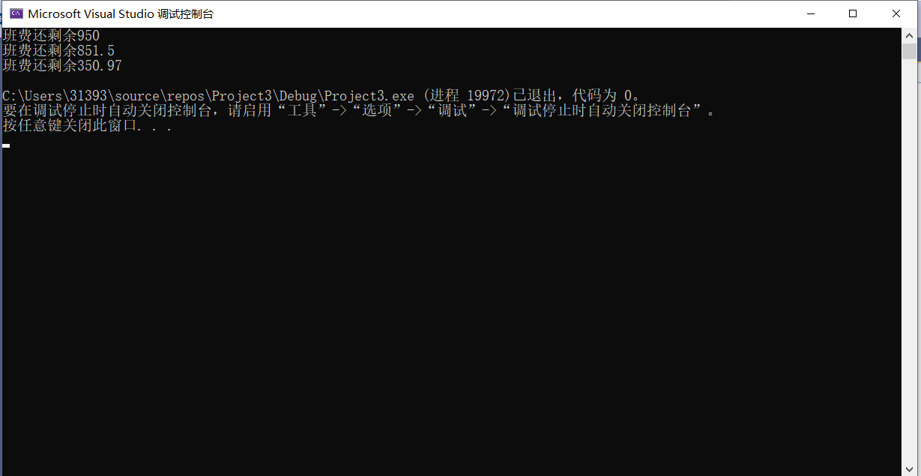

总结：

这次实验，让我理解了静态成员的作用，并在上机实操中加深了理解。